(Approx. 1,012 words)

It’s almost here…when?...soon…when is soon?
by Lou Torraca, President, The TUG MOAA Computer User Group, Hawaii
www.the-tug.org
Af06hi (at) gmail.com

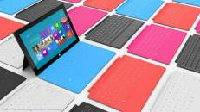
For those who follow computer news, you probably know that “it” is Windows 8, Microsoft’s latest, and from many reports, best OS. Before I tell you a bit more about 8, I have a suggestion. I know some of you are considering getting an iPad…my suggestion is wait. Microsoft recently introduced their answer to iPad called Surface, but not all the details are out there yet. So, I would also suggest u take a look at: http://www.microsoft.com/surface/en/us/default.aspx
The picture, above shows some of the options available.

Whenever a new Windows operating system (OS) comes out, we inevitably find ourselves wondering if it's worth the hassle of upgrading. What will it cost to upgrade? The good news is the two recent options that Microsoft announced. If you are in the market, right now, for a new PC, you will be able to upgrade to Windows 8 pro when it’s released (all the indications are that it will be released in October) for $15. And, for those who want to upgrade from Vista, XP or 7, it’s $40. Will you lose all your favorite features? So now that Windows 8 is imminent, we have to ask ourselves if it will be that much better than Windows 7 (or even Windows XP, for those of us who never bothered upgrading last time). TECCA asked those same questions and dug through the reviews to find some answers. What can you expect from Windows 8? Is it time for you to make a change?

1. Unified PC, tablet, and smartphone
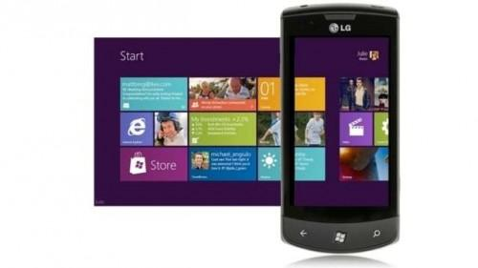
Windows 8 aims to successfully unify all your devices, from your PC to you tablet to your smartphone. While this claim may sound too good to be true, so far, it looks like a promise Microsoft will keep.

Earlier this year, Samsung showed off a tablet running Windows 8 at the 2012 Consumer Electronics Show. And during an event held in June, the company presented a duo of tablets collectively called the Microsoft Surface. (See my comment, above.) The more basic of the two runs Windows 8 RT, one of three flavors of Windows 8. The more high-end version built with professionals in mind runs Windows 8 Pro.
Unfortunately, current Windows smartphones won't be upgradeable to Windows 8. But if you do get a Windows 8 smartphone, tablet, and computer in the future, you'll be able to sync your Metro user interface (UI) apps, among other things, across devices. You can even access your computer and your mobile devices using the same login details.

2. The all-new Metro user interface
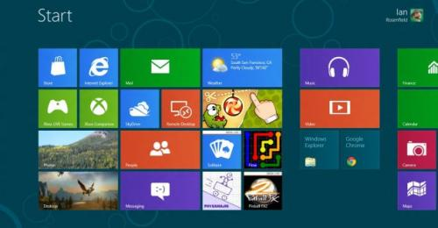
We mentioned the Metro UI above, but what is it exactly? Previous versions of the Windows operating system feature similar aesthetics, but Windows 8 looks drastically different. The Metro UI displays Windows 8 apps right on your home screen as a mosaic of tiled boxes of different sizes, shapes, and colors. These tiles represent everything from apps running in the background to incoming email and messages to shared photos.

The app tiles update in real time for events including Twitter messages and upcoming calendar events. Metro UI renders well on tablets, especially since if you own a tablet, you're already used to swiping between home screens. But on computers, you have to get used to scrolling sideways to get to the home screen where you placed the app you want to launch.

3. More energy-efficient than Windows 7
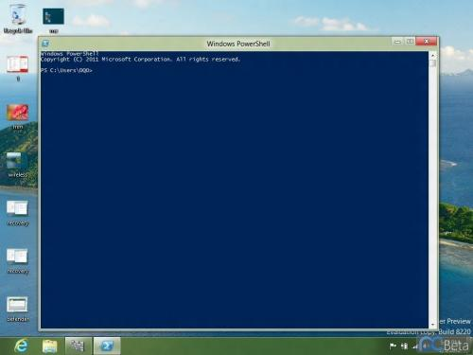
According to a test by Tom's Guide, Windows 8 uses less power than Windows 7, keeping your laptop running longer. Windows 8 is configured to save battery life by dropping to a low-power state (longer than Windows 7 can) when you're not doing anything power-intensive. It also shuts down ports you're not using rather than running them needlessly.

4. Speedier performance
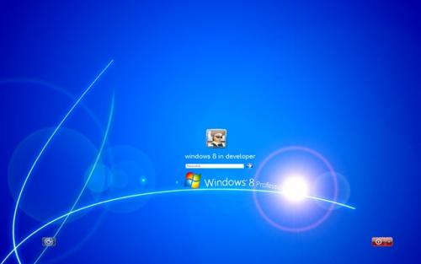
Is Windows 8 faster? The answer is a resounding yes. The Consumer Preview version of Windows 8 has so far proven to be faster than older Windows versions in various speed tests. In fact, Lifehacker found that Windows 8 boot times can be up to 25 seconds faster than Windows 7 boots, and the new OS can pretty much do most tasks a smidge faster than the older OS. Sure, it's just a few seconds shaved off, but those few seconds are pretty noticeable when you spend a lot of time on the computer.

5. Easier to use with multiple monitors
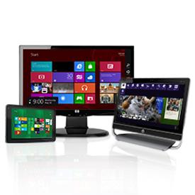
If you decide you want a computer setup comprised of more than one monitor, then Windows 8 may be the operating system that will work best for you. Designed with multi-monitor use in mind, it lets you customize your taskbar settings for each monitor or open window. Microsoft even lets you customize a different desktop background for each monitor or stretch one image over multiple monitors. You'll also be able to run slide shows over multiple screen screens.

6. Limited third-party browser access
Recent reports indicate that Windows 8 RT, one of the platform's versions meant for use on devices with ARM processors such as one of the Surface tablets, could limit third-party internet browsers. Those of you who prefer Firefox or Chrome over Internet Explorer may be out of luck. This has yet to be confirmed as of this writing, but keep it in mind if you're buying a new Windows computer or tablet in the future.

7. No support for Windows XP by 2014
Windows 7 and Windows XP are two of the most popular operating systems at the moment. If you're running Windows 7, you're probably fine until 2020, but if you're an old XP faithful, you might have to rethink your position and upgrade to Windows 8 soon. As of April 2014, Microsoft plans to stop supporting Windows XP.

So, there u have it…it’s up to u to decide. Whatever your decision, have fun and be careful out there on the www.

Aloha, Lou

Check out Lou’s Technology in Plain English articles at Around Hawaii / Oceanic time Warner’s Community Website http://www.aroundhawaii.com/technology_in_plain_english.html

